Sri Lanka Institute of Information

Technology



Lab Submission

<Lab sheet 10>

**<IT24103815>**

**<Fernando W.P.S.>**

**IT2120 - Probability and Statistics**

B.Sc. (Hons) in Information Technology

Exercise

1. A vending machine owner claims that customers choose the four snack types (A, B, C, D) with equal probability. To test this claim, a researcher records the number of purchases for each snack type during one week and results are given below.



1. State the null and alternative hypotheses for the test.

Answer: -

1. Perform a suitable chi-squared test to test the null hypothesis.

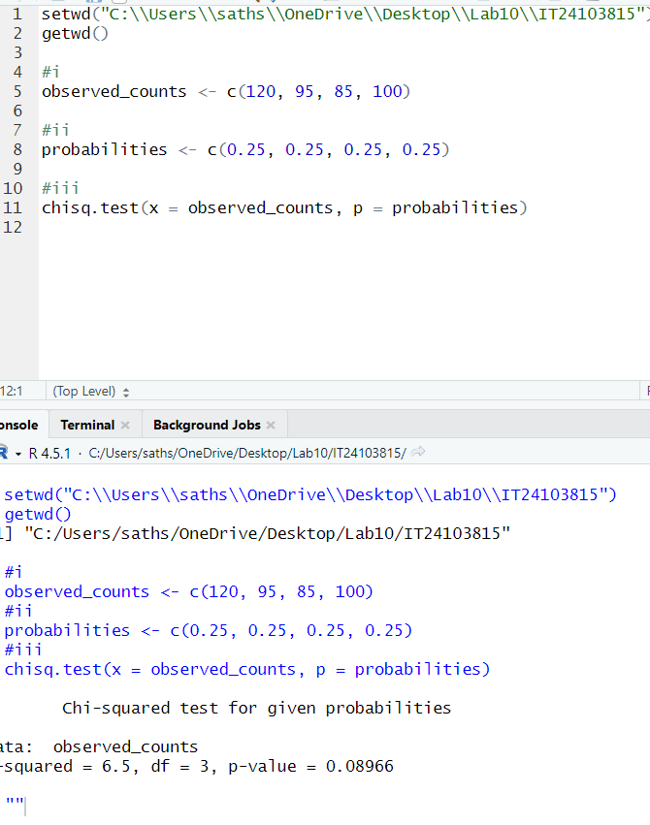

Answer: -

1. Give your conclusions based on the results.

Answer: -

